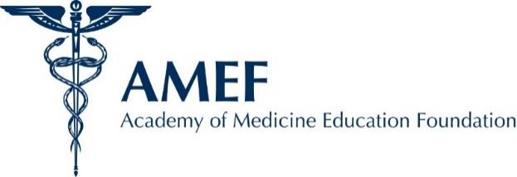

AMEF is the charitable component of the Academy of Medicine of Cleveland & Northern Ohio (AMCNO), which is celebrating its 200th anniversary of organized medicine in 2024.

There are several ways to donate to the foundation.

Please make checks payable to AMEF
Academy of Medicine Education Foundation (AMEF)
6111 Oak Tree Blvd., Ste. 150
Cleveland, OH 44131

OR

Please charge my credit card:

Name ______________________________________________________________________________
Card number ___________________________________________________________________
Expiration date (month/year)____________________________ CVV _____________
Address ______________________________________________________________________________
City ________________________________________ State _____________ Zip _________
Email address ______________________________________________________________________
Signature _________________________________________________________________________
My donation is a:
- Tribute in memory of:  ___________________________ | - Tribute in honor of:  ___________________________ | - On the occasion of:  _________________________

Please select the amount you would like to donate:
- $5,000 | - $1,000 | - $500 | - $100
- $60 – Honoring 60 years of giving | - $250 Annually – Dr. Lower Legacy Member | - Other Amount  __________
All donations are fully tax-deductible. For more information about AMEF, please visit www.amcno.org and click on the AMEF tab at the top of the homepage.

